**PROBLEM SET 2**

**Q1 (a)** Finding lambda:

$\frac{d}{dx}\left(\sqrt{\frac{2}{π}}*x^{2}*exp\left(-\frac{x^{2}}{2}\right)\right)=0$**=> x*=sqrt(2)=1.41**

$$\frac{d}{dx}(2*\frac{x}{lambda^{2}}*exp\left(-{\left(\frac{x}{lambda}\right)}^{2}\right)=-((4*x^{2}-2*l^{2})*exp(-x^{2}/l^{2}))/l^{4}$$**putting x =sqrt(2) and making it equal to 0**

* **Lambda = 2**

**Finding A**

$$\sqrt{\frac{2}{π}}*x^{2}*exp\left(-\frac{x^{2}}{2}\right)=A*2*\frac{x}{lambda^{2}}*exp(-{\left(\frac{x}{lambda}\right)}^{2})$$

**A= $sqrt\left(\frac{2}{pi}\right)*(\frac{xs}{2})*lambda^{2}*exp(-\left(\frac{xs^{2}}{2}\right)+\left(\frac{xs^{2}}{lambda^{2}}\right))$** = 1.36

**Q1 (b)**

**Code attached**

**Q1 (c)**

Fails= 508 times out of 10,000

**Q1 (d)**

** **

It looks evenly distributed for all p values. That means it has equal probability to give any of the p-values.

**___________________________________________________________________________________**

**Q2 (a)**



**Based on the best-fit line from the above figure, we can find the slope (m).**

**m=-0.156**

**so it decreases with N^0.156**

**Q3 (a)**

To visually show that it is not biased towards any direction, I plot a scatter plot of all the 1e4 points:

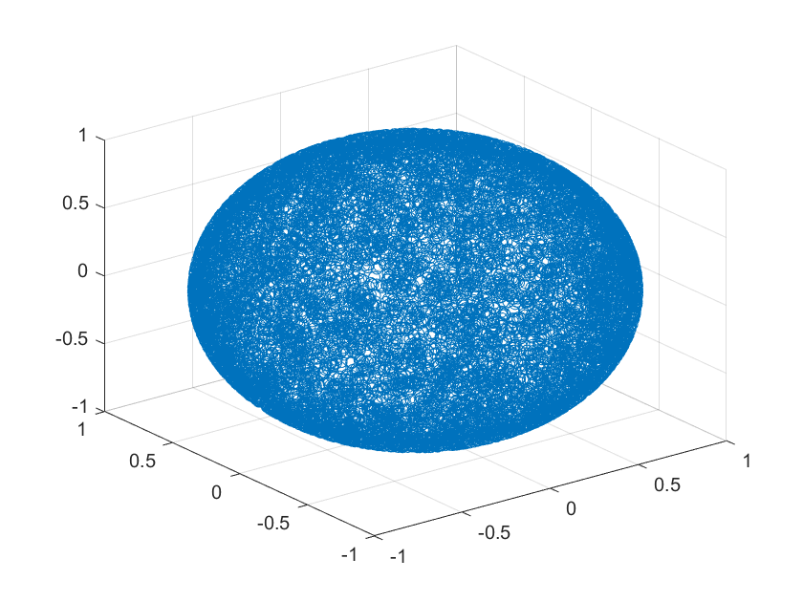

As seen above it look quite uniform.

But to statistically show, I create four quadrants of the sphere.

Q1=X Y Z, Q2=X Y-Z, Q3=X -Y Z, Q4=X -Y -Z, Q5=-X Y Z, Q6=-X Y -Z, Q7=-X -Y Z, Q8=-X -Y -Z

Below is the bar chart for the result:



It looks evenly distributed among the 8 quarters.

**Q3 (b)**

**Probability distribution:**



**Distribution comparison with exact solution**



**Logarithmic distribution**



**Q3 (f)**



**Q3 (g) Code attached**